Hour 1: Introduction to React and Virtual DOM
1. What is the Virtual DOM?
- Explanation: The Virtual DOM is a lightweight copy of the actual DOM (Document Object Model). React uses this to update only parts of the UI that need changing instead of reloading the whole page. This approach makes React faster and more efficient.
Code Example
Imagine a simple button counter where only the number updates, not the whole button.
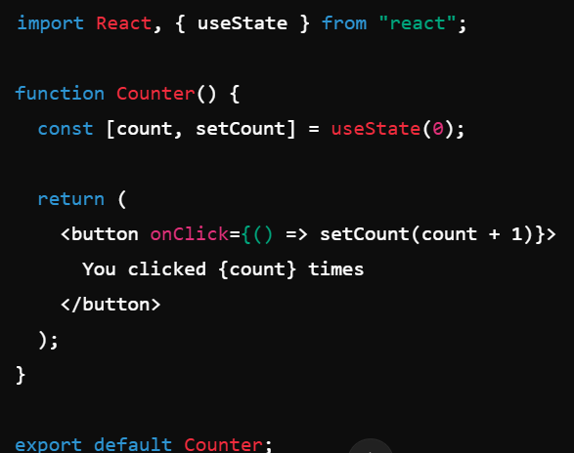
Explanation: Here, when we click the button, React only updates the part showing the count instead of refreshing the entire button or page.

Hour 2: Props and State
2.1 Props
- Explanation: Props (short for "properties") allow you to pass data from a parent component to a child component. Props make components reusable and dynamic.
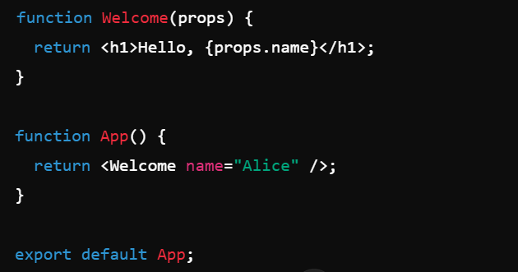
Explanation: Here, name="Alice" is a prop passed to the Welcome component, which it uses to display a personalized message.
2.2 State
- Explanation: State is data that a component tracks internally. Unlike props, which are passed from outside, state is managed within the component. When state changes, React automatically re-renders the component.
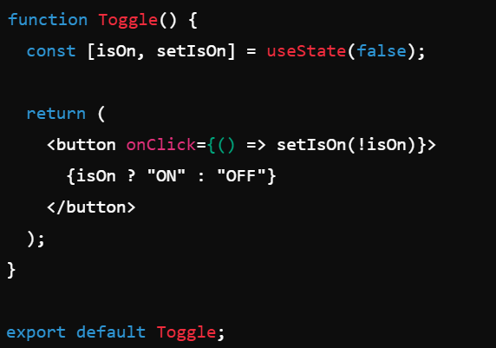
Explanation: useState manages the isOn state, and every time the button is clicked, it toggles between "ON" and "OFF."

Hour 3: React Hooks
3.1 State Hooks (useState)
- Explanation: useState is a hook that lets you add state to a functional component.
const [count, setCount] = useState(0);
3.2 Effect Hooks (useEffect)
- Explanation: useEffect allows you to run side effects in your components, such as fetching data, directly after rendering.
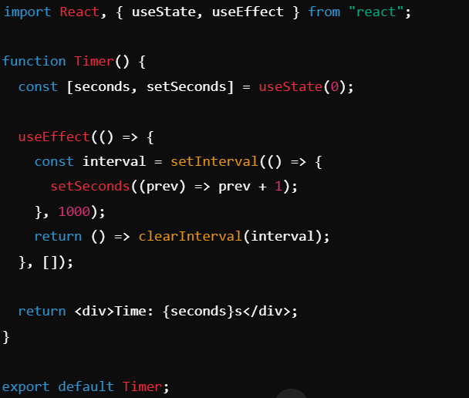
Explanation: This example creates a timer by updating seconds every second. useEffect runs the interval on mount and clears it on unmount.
3.3 Context Hook (useContext)
- Explanation: useContext allows you to use React’s Context API, which is helpful for sharing state between components without passing props down manually.
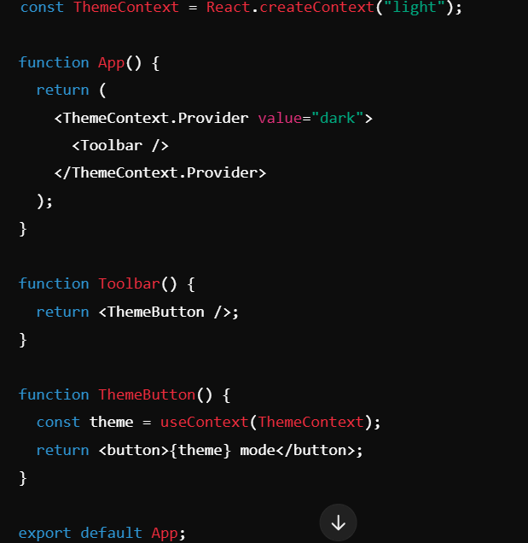
Explanation: useContext accesses the ThemeContext value in ThemeButton, showing "dark mode" as the output.

Hour 4: React Router
4.1 Basic React Navigation
- Explanation: React Router lets you handle routing (page navigation) in single-page apps. Use it to switch between different components (pages) based on the URL.
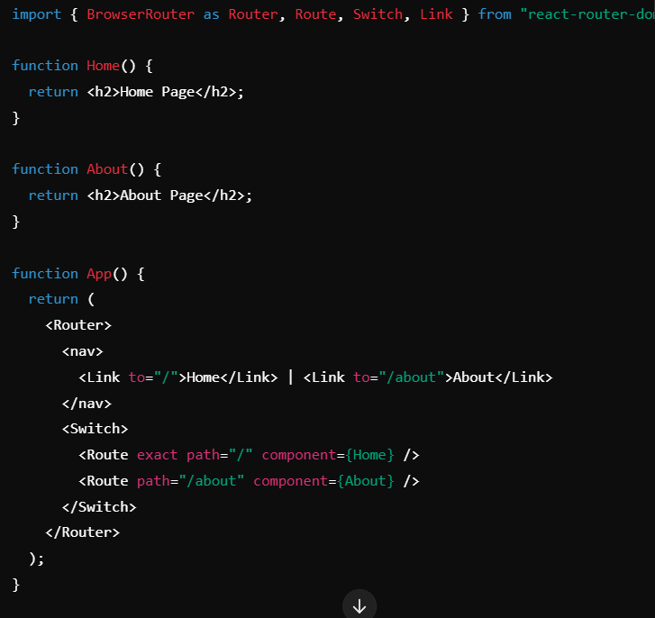
Explanation: This setup navigates between the "Home" and "About" pages when you click the respective links.

Hour 5: Global State Management with Context API and Redux
5.1 Context API for Global State
- Explanation: The Context API allows you to create global state accessible throughout the app
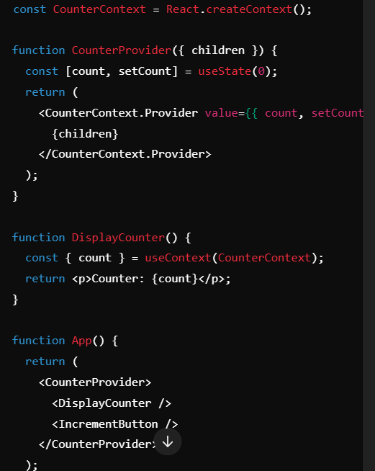
Explanation: Here, CounterProvider allows DisplayCounter to access the count from any part of the app.

Hour 6: API Integration
6.1 Setting Up Axios for API Calls
- Explanation: Axios is a library for making HTTP requests. Install it with npm install axios.
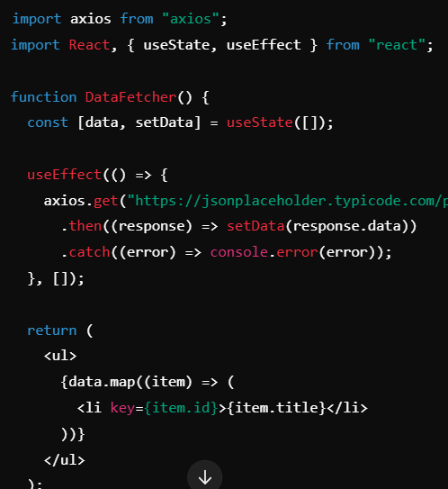
Explanation: This example fetches data from an API and displays each post's title.

Hour 7: Handling Errors and Async with API
- Explanation: Error handling ensures the app manages issues smoothly, while async functions manage tasks that take time to complete, like API calls.
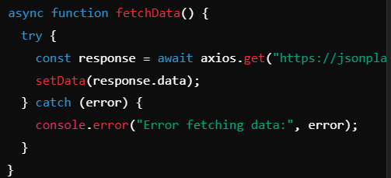
Explanation: This code wraps the API call in try...catch for smooth error handling.

Hour 8: Installing and Configuring Tailwind CSS
8.1 Install Tailwind CSS
- Explanation: Tailwind CSS is a utility-first CSS framework for rapid UI development. Install it with npm install tailwindcss.
Setup Example
- Add Tailwind CSS to your project with npx tailwindcss init.
- Configure tailwind.config.js.
- Add Tailwind directives to index.css.
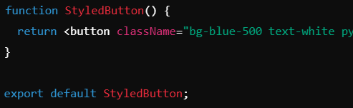
Explanation: Tailwind classes style the button without writing custom CSS.

